24.80: a) The capacitors are in parallel so:
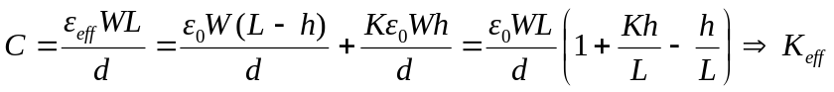
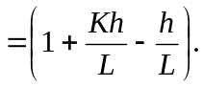
b) For gasoline, with 
full: 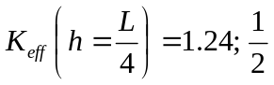 full: 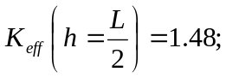
full: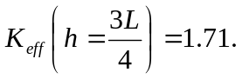
c) For methanol, with 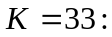
full: 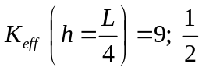 full: 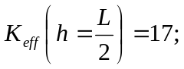
full: 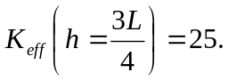
d) This kind of fuel tank sensor will work best for methanol since it has the greater range of 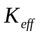 values.

